**DAILY ONLINE ACTIVITIES SUMMARY**

|  |  |  |  |  |  |  |  |
| --- | --- | --- | --- | --- | --- | --- | --- |
| **Date:** | 24-06-2020 | | | | **Name:** | Gudugunti Anirudh | |
| **Sem & Sec** | IV - A | | | | **USN:** | 4AL18CS023 | |
| **Online Test Summary** | | | | | | | |
| **Subject** | | ----- | | | | | |
| **Max. Marks** | | ----- | | **Score** | | ----- | |
| **Certification Course Summary** | | | | | | | |
| **Course** | C programming | | | | | | |
| **Certificate Provider** | | | ----- | **Duration** | | | **11.5 hrs** |
| **Coding Challenges** | | | | | | | |
| **Problem Statement:** 1: Program to Split the array and add the first part to the end. An array of numbers is taken as input and split it from a specified position, and move the first part of array add to the end. | | | | | | | |
| **Status:** Completed | | | | | | | |
| **Uploaded the report in Github** | | | | yes | | | |
| **If yes Repository name** | | | | https://github.com/alvas-education-foundation/anirudh_gudugunti/tree/master/daily_progress | | | |
| **Uploaded the report in slack** | | | | yes | | | |

**Online Test Details: Not conducted**

Snapshot of certification course:

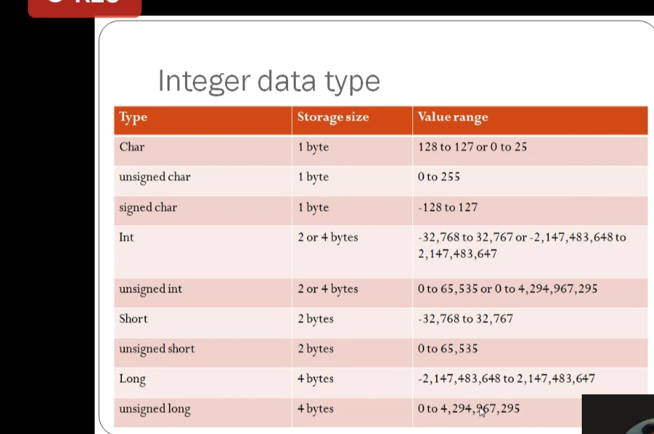

: Today i have attended webinar on C fundamentals.

: In that session topics covered are: variables,constants,data types,arrays, functions,derived Data types and many other basic fundamentals.

: After completing this we had a basic quiz.

**Online coding:**

Problem 1: (using Python) Program to Split the array and add the first part to the end. An array of numbers is taken as input and split it from a specified position, and move the first part of array add to the end.

